**Class Attendance Mobile App**

Use Case Specification

Submitted to:

Asst. Prof. Ma. Rowena C. Solamo

Faculty Member

Department of Computer Science

College of Engineering

University of the Philippines, Diliman

Submitted by:

Atienza,​ ​John​ Oliver

Austria,​ ​Ronnel​​ Roi

Gabriel,​ ​Kristianne​ Arielle

In partial fulfillment of academic requirements

for the course

CS 191 Software Engineering I

of the

1st Semester, AY 2017-2018

***Unique Reference:***

The documents are stored in the GitHub repository:

<https://github.com/rbaustria/ClassAttendanceMobileApp>

***Document Purpose:***

The document provides the Use Case specification of the software, Class Attendance Mobile App.

***Target Audience:***

The target audience of the document are: the developers of the software, future developers who wish to extend it, and the professor.

***Revision Control***

*History Revision:*

|  |  |  |  |
| --- | --- | --- | --- |
| ***Revision Date*** | ***Person Responsible*** | ***Version***  ***Number*** | ***Modification*** |
| 10/08/17 | Arielle Gabriel | 1.0 | Initial Document |
|  |  |  |  |

*Use-Case Name*: 2.1 Add a Class

*Description:* This use-case adds a new class to the list of existing classes. The teacher will input information about the class. The application will then check if the information entered are valid and no class with same identification already exist, if there is none, a new class will be created.

*Preconditions:* NONE

*Flow of Events:*

|  |  |
| --- | --- |
| ***Scenario Name*** | ***Description*** |
| Scenario 1 (Basic Flow)  Teacher successfully creates a new class | 1. Teacher opens the create a class module. 2. The teacher inputs the information about the class. 3. If there is no existing class with same identification name and the information is complete, a new class is created with the information entered by the teacher. |
| Scenario 2  Teacher fails to create a new class | 1. Teacher opens the create a class module. 2. The teacher inputs the information about the class. 3. If there an existing class with same identification name or incomplete information was entered, the application will display an error. |

*Activity Diagram of the Flow of Events:*

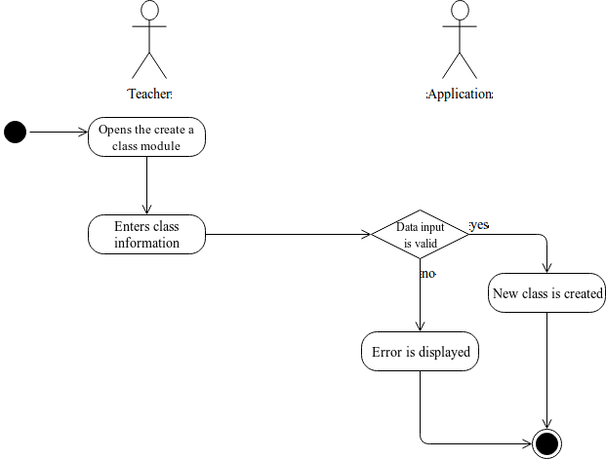

*Postcondition:* A new class is created or none.

*Relationships:* NONE

*Special Requirements:*

NONE